VOIP lab experiment#15
Creating a time condition in the PBX

Installation and Repair of Telecommunications Equipment

Name of student:________________
Group Number:_________________
Date:_________________________

The purpose of the lab is to create a time condition for the company in the PBX. Refer this lab with the time group laboratory
- Enter a time condition name
- Time group
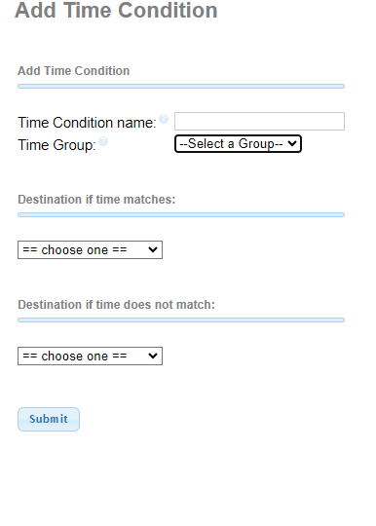

- If the Time matches, choose an Announcement.
- In the destination if the time does not match choose an extension/mailbox.
- Click on submit and then apply the config

